**IFOUND WEB APP**

**PROJECT**

Name – Faizan Ashraf

Collage Name – GIET UNIVERSITY GUNUPUR (2nd year B.tech CSE)

LinkedIn profile - <https://www.linkedin.com/in/faizan-ashraf-5290971aa/>

GitHub profile - <https://github.com/faizan-code>

|  |  |
| --- | --- |
| PAGE NUMBER | WORK DONE |
| 1 | Introduction |
| 2 | Aim of the organisation and how I will approach my work . |
| 3 | A demo project done by me to show my approach |
| 4 | Graphical approach for my demo project |
| 5 | My ML approach for doing the organisation work |

The two main aims of IFOUND WEB APP

1. Is to connect people who lost their item and people who found it.
2. To find missing children

For the first Aim –

The person who has lost his items needs to give the description of his item That is**DATA**which is the most necessary thing to match that data and match it with the data another person will give when they find a similar item.

1) Colour

2) Shape

3) Any Sticker

4) Number in the number plate (if it’s a vehicle).

5) Product Id number if it is written in the items.

6) Lost **/**Found Date and Time

7) Location where the person lost the item.

8) Company

9) Number of wheels (If it’s a vehicle)

10) Item type

All the above data will also be filled by the person who finds the items. Then our ML model will use both the data and tell the person who is searching for his item with whose data his product description Matches.

Here I have created a small to show how I will do the work . I will also share the repository link .

**Suppose the vechile we are finding is**



1. Created a data of vehicles in excel.

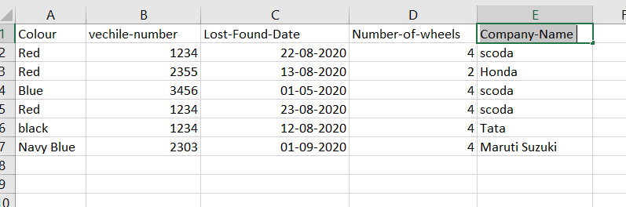

1) This excel file contains all the data the person who finds the vehicles and the person searching for the vehicles have provided then we can use different Data Analysis technique to find the similarities between the data and do the work.

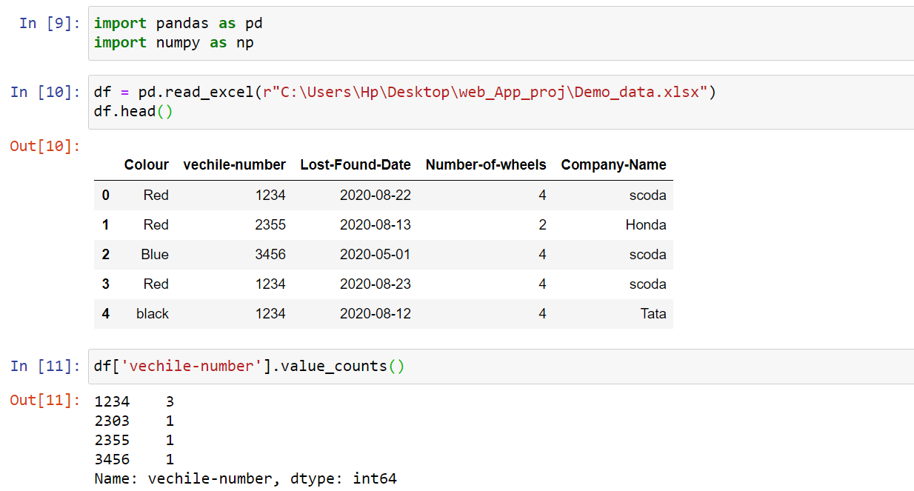

Now with the above analysis, we have the information that vehicles with number 1234 are 3 in number. Then we need to find the company of the vehicles the person is looking for and there we succeed in finding the lost vehicle of the person.

.

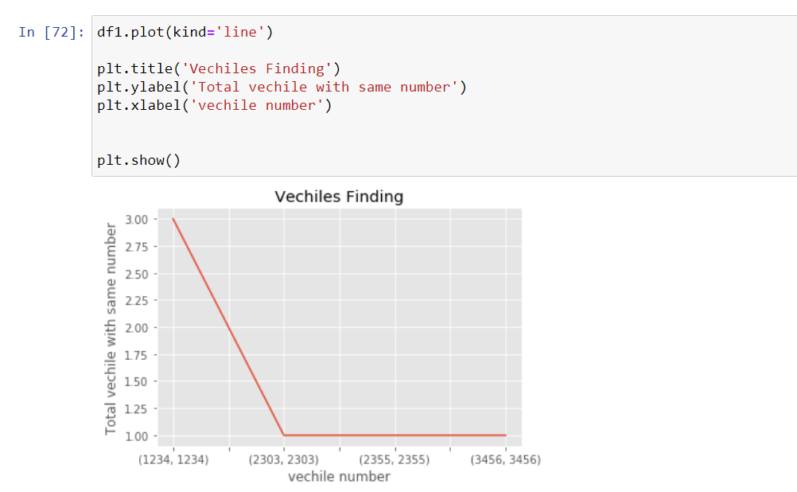

Here is a graph to show the analysis.

This is just a basic idea about how I will step towards completing My work as due to the lack of data I am unable to perform many ML algorithms to train my data.

Below I have mentioned a few More ways about how I can contribute towards the Aim of your Organisation.

1) With a large amount of data, I can **apply the KNN** algorithm to finds similarities between the items.

2) I will train my Model with unique variables which are mostly different among different Items like – Product ID, Vehicles Number, Company Name, Any mark in the items.

3) I will use different visualization Techniques so that our users can find working in our app very easy to understand.

4) Apart from the KNN algorithm I can also use Decision Tree, SVM

5) I have done a project which is a bit similar to the aim of the organization. LINK - <https://github.com/faizan-code/Bank-Loan-project->

6) Similarly for the second aim of your organization my steps towards finding missing Children would be the same just the data used will be different.

Here I have Finished My demo project and described how I will approach the organization.

I hope the respected Interviewer will like my work hope I will get a chance to work with the organization and Improve my skills and serve more growth to the organization.

  ------ END ------